**Frequently Asked Questions**

**Q, Are you inflatables safety tested ?**

**A, Yes they are we annually safety test all our inflatables a bit like a car Mot .All our inflatables tests are registered with a scheme called pipa** r**elating to the registration of each inflatable.**

**Q, our venue requires proof of insurance is this possible ?**

**A, Of course we hold full public liability insurance of**  - £5,000,000 which we are happy to send a copy direct to your venue.

**Q) How do I book?**

A All booking is done online through the website which has a live availability checker .No equipment is reserved until the deposit is paid and be automatically relisted for sale unless a deposit is paid .

**Q) How much notice is needed to make a booking?**

A) We always recommend you book as early as possible but we can take bookings at short notice.

**Q) What days and times can we hire from you?**

A) We are open 7 days a week and can deliver & collect subject to availability .our latest collection is 6 pm for children’s castles late pick up option available from 6-9 pm for £20 . we will usually book you into a delivery slot based on our delivery route if your booking is at home . bookings for set times in halls will take priority .If you booking is over two dates you will need to book the equipment for two days .

Where do you deliver too ?

The areas we cover for free delivery are within a ten mile radius of our base in Hemel Hempstead HP2 7DU , Redbourn, Kings Langley, Chipperfield ,Berkhamsted , Cow roast ,Apsley ,Abbotts Langley ,Bovingdon, Flaunden ,Gaddesden row and gaddesden Villages . Ashley green

Where does a delivery charge apply ?

Any area over 10 miles from Hp2 4YJ

Some areas of Tring ,Ivinghoe , Dunstable , St Albans ,Harpenden , pitstone ,

**Q) How much are your Castles, Soft play, etc..**

A) Prices vary, please see each individual item for hire price.

**Q) What do I get with my castle booking?**

A) Price includes delivery (a delivery charge will apply for those located outside the free delivery area) , Set up & inflation & then deflation and pack away at the end of the booking. Each castle is supplied with a Blower, Sand bags or Pegs (depending on surface) and safety mats which will set it all up ready for use.Hall or venue hire is not included unless you have booked either of our hall hire packages . .

**Q) What do I get with my soft play booking?**

A) All soft play bookings include floor mats and ball pond balls as standard . Price includes delivery (a delivery charge will apply for those located outside the free delivery area) If the package includes a bouncy castle then it also include, Set up & inflation & then deflation and pack away at the end of the booking.

**Q) How long do I get the equipment for?**

A) The equipment stays with you for the length of the party, in some cases we may drop it off extra early and collect extra late (if the venue allows) due to having to deliver and collect from other customers.

**Our party finishes later than 6 pm can we have a later pick up ?**

**We can offer a late pick up fee of £20 to extend your booking time upto 9 pm please check this option is available at time of booking**

**Q) Can we have the equipment overnight?**

**We do not have an over night rate as it’s not possible to clean castles or equipment on the same day but equipment can be booked for two days .**

A) **Q) Do you require a deposit? .**

A) Yes, A booking is not secured until a deposit is paid **If your booking falls less than three weeks before the total amount will be due to secure the booking**

When do we have to pay for our booking ?

Full balance is due 3 weeks before by transfer or on the day if paying cash

**Q, Do you allow face paint or glitter ?**

**No we do not face paint ,silly string , party poppers , poster paint and craft glue can also stain the inflatable permanently . confetti from inside balloons** including the foil ones sticks to the inflatables and if they become wet can stain. . .In the first instance there will be a **cleaning charge of £65** .If the stain cannot be removed and the unit material has to be replaced we will obtain a repair or replacement quote from our repairers Top Marks inflatables or an independent repairer of your choice .The average price of a standard 12x12 bouncy castle new is £1200 should the cost of the repair exceed the price of the castle you will be liable for the replacement cost . soft play will depend on the size and design of the piece that is marked . We will not leave a castle on site if you have booked a face painter . you are signing to say you accept this when you book .

**Q) How do I pay?**

A) We accept card payments ,bank transfer and Cash

**Q) What if I need to cancel?**

A) For indoor bookings You can cancel at anytime, The deposit is non refundable . If the cancellation is given with at least 14 days notice the deposit can be used against a future booking within a 12 month period any hire fees paid will be transferred to your new event date . After you have returned the booking form , paid the deposit and we have confirmed the booking by email a contract exists between us the equipment you have booked is reserved for you until the date of your party . If you **fail to notify us at all that your event is cancelled** the **full value of the booking will be due** and any travel costs incurred by arriving at the venue will also be payable .

**Can I reschedule ?**

**Hi yes you can we will transfer all hire payments to a new booking date . once transferred the value will be valid for 12 months but not refunded .**

**Q) What if the weather is really bad?**

A) We reserve the right to cancel due to adverse weather conditions .In the case of excessive rain or unsafe wind speeds we do not refund. If you are using the inflatable outside, be aware of the weather. BS EN 14960 recommends that the maximum windspeed in which inflatable play equipment should be used outdoors is 38 km/h which is Force 5 on the Beaufort Scale (small trees in leaf begin to sway). The best way to measure this is by using an anemometer. Regardless of the actual weather on the day if the met office prediction is above safe levels we cannot hire as our insurance becomes invalid . In the case of rain light showers are fine castles and all related equipment cables etc are rated for use outdoor use . we will contact you if there is predicted continual showers to confirm your event is going ahead in the case of windspeeds we will contact you to give you time to find an indoor venue . once we have delivered a castle we are not responsible for events outside our capabilities like managing the the weather and will not refund if the weather changes regardless of the time it has been used for . . In the event of heavy rain, it is strongly recommended that the Inflatable REMAINS ON but not used . Any wetness, including bubbling (which is normal) can be dried with a towel once the rain has stopped . The blower should be covered to ensure water does not get inside

**Q) Can I have the equipment set up on outside the venue on grass or in my garden?**

A) Soft Play is recommended for indoor use only however if good weather Is predicted outside is fine .if you are worried about the weather we can supply a gazebo soft play cannot under ANY circumstances get wet , However, Bouncy castles can only be set up on grass, The area should be free of dog fouling or any other debris which may damage or stain the castle e.g garden toys, swings, slides, patio furniture, rubbish etc

**Q) Can I have the castle set up on concrete or Astroturf decking or paving ?**

A) no sorry we do not set up outside on anything other than grass as we will be unable to peg it down ( only applicable to outdoor hire ) all anchor points must be able to be pegged in without obstruction .its is illegal not to have equivalent weight 165kg of weight per anchor point if outdoor and using sandbags .The minimum anchor points on a castle is 6 equates to 990kg of sand !

**Q) Can i have a castle set up on gravel?**

A) No, unfortunately under no circumstances can we set any inflatable up on gravel.

**Q) How long does it take to set up/inflate/deflate/pack up the inflatable?**

A) On average each castle can take anything from 10-30 mins to set up and then pack away. Times vary depending on each individual castle due to sizes so please allow the maximum amount of time at the beginning and end of each booking. If you book a whole package with soft play or play park you must allow no less than 45 minutes we will not be responsible if you incur charges for extra venue time due to not allowing sufficient set up /clearing time .

**Q) How much space is needed around the castle?**

A) For an outdoor hire you must have 1.2 metres free space around the back and sizes of the castle and 3 metres at the front this space can not include washing lines ,paths,slabs, trees .Access must be ground floor , a minimum of a metre wide and clear of obstructions . Don’t forget to check your venue ceiling height ! There must be a minimum of one metre of clear space above a castle not obstructed by beams , light fittings or fixtures

For Outdoor / Garden hires access to the garden must be direct and **not through the house** the garden must have its own access such as a side gate . , castles cannot be put up on anything outdoor except real grass ..

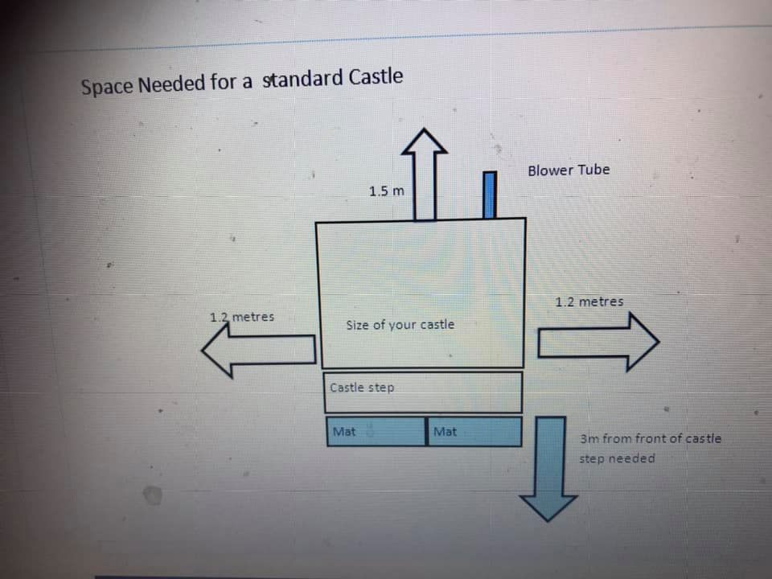

Q, What do I need to do before you deliver ?

A) You will need to ensure that access is clear we need a minimum of 1 metre clearance of clear space to deliver the castle suitable for trolleys access must be **ground floor** . All gardens MUST have clear side access we cannot and will not deliver equipment through an address and you must have permission of the landowner if the garden area is communal or on public land this is usually the local council .

**Q) When I hire the castle is there anything I need to provide?**

A) We supply all the hardware you will need for the castle, you will need to provide a 240 volts mains power supply or two sockets for the disco castle . if mains power is not available we cannot supply a castle . Access to power must be less than 20 metres away .

**Q) Is there an age limit for children using the castle?**

A) Yes all our castles have individual age limits, see item description for info . This does not apply to adult castles .

**Terms & Conditions of Little House**

**Of Bounce**

1 All our inflatables are designed for use by children of up to 65kgs and should not be used by children over the age of 14 (Not applicable to an adult hire )  
2 No food drinks or chewing gum to be allowed on or near the Inflatable.  
3 All shoes, glasses, jewellery, badges must be removed before using Inflatables.  
4 No smoking or barbecues near Inflatables at any time.  
5 Climbing, hanging or sitting on walls is dangerous and must not be allowed at any time, some of our inflatables are designed to have low walls for supervision purposes, on these types of inflatables this rule is exceptionally important, especially when the castle is erected on hard surfaces indoor .

6Two responsible adults must supervise the Inflatable at all times, If not adhered to and in the event an accident does occur you may be liable under your own insurance we are not responsible for inflatables in your care **nor must you move any inflatable** or equipment once it has been set up by us .  
7 Always ensure that the Inflatable is not overcrowded, and limit numbers according to the age, size and stature of children using it. Try to avoid large and small children from using it at the same time as this can only lead to accidents.  
8 Ensure that children are not pushing, colliding, fighting or behaving in a manner likely to injure or cause distress to others.  
9 Please allow at least 30 mins after your booking time for us to arrive on site and begin packing down. This does not include packing away.  
10Do not allow anyone to be on the Inflatable during inflation or deflation as this can be extremely dangerous.  
11 never walk away from a bouncy castle until it has fully deflated as small children can be caught up inside, this can lead to suffocation.  
12 Do not allow anyone to bounce on the front safety step as a child could easily bounce off the inflatable and get hurt. The step is there to assist users in getting on or off only.  
13 Ensure that no one with a history of back or neck problems or who suffers from a heart complaint uses the Inflatable or anyone who is feeling unwell or suffering the effects of alcohol or drugs & Pregnant women may not use any equipment at anytime, In the event that someone is injured, Remove all other children from the unit as safely & as smoothly as possible and DO NOT move the individual, leave the inflatable switched on and dial 999 immediately for advise.  
14 Ensure that Children are not attempting somersaults and are clothed appropriately.  
15Ensure that an area of 6 feet (2 meters) around the unit is completely clear and ensure the area in which the castle is to be erected is completely swept of debris & that all washing lines, children’s toys and especially Dog droppings, before our arrival it is **not** advisable to cut grass before we attend .

16 The Inflatable should not be used if it becomes wet on the jumping area. If no shower cover is fitted, and, in the event of rain, the unit should not be used.

17 In the event that the fan stops working, ensure all users get off the inflatable immediately to avoid suffocation. The most common faults are the fan tipping over due to too overloading on the castle or the air vents becoming obstructed by leafs, debris & carrier bags etc, if this is the case, then please remove the obstruction. If the problem persists, then please call us immediately on 01442 590138 .

18

**We will not refund** you if the building/ garden space is unsuitable once the castle is unrolled every castle is supplied with measurements of space required please check if you are unsure don’t forget the ceiling height ! Most venues we have hired before so can advise if your not sure if your venue is suitable we are run by a Rpii qualified operator and **we will not leave a castle if we consider the set up to be unsafe** . **by returning the booking form and paying the deposit you are deemed to be accepting these terms and conditions .**